1.Create a GitHub account :-
Account has been created.
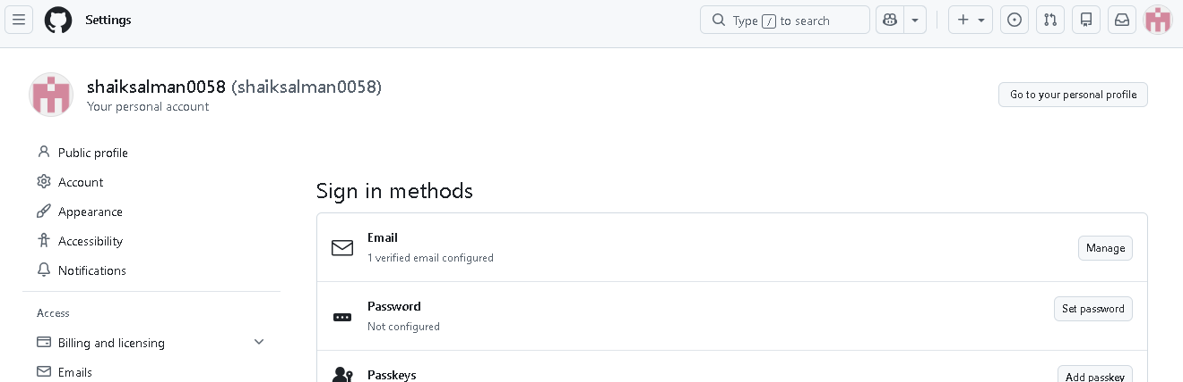

2.Set up MFA (Multi-Factor Authentication) for the GitHub account using a mobile app:-
To set up MFA (Multi-Factor Authentication) for your GitHub account using a mobile app (Authenticator App), follow these steps carefully.
MFA adds an extra security layer. After enabling it, GitHub asks for:
- Your password
- A code from your mobile app
This protects your account even if someone knows your password.

Step 1: Install an Authenticator App on Mobile
Download any one app:
- Google Authenticator
- Microsoft Authenticator
- Authy
Install one app on your phone.
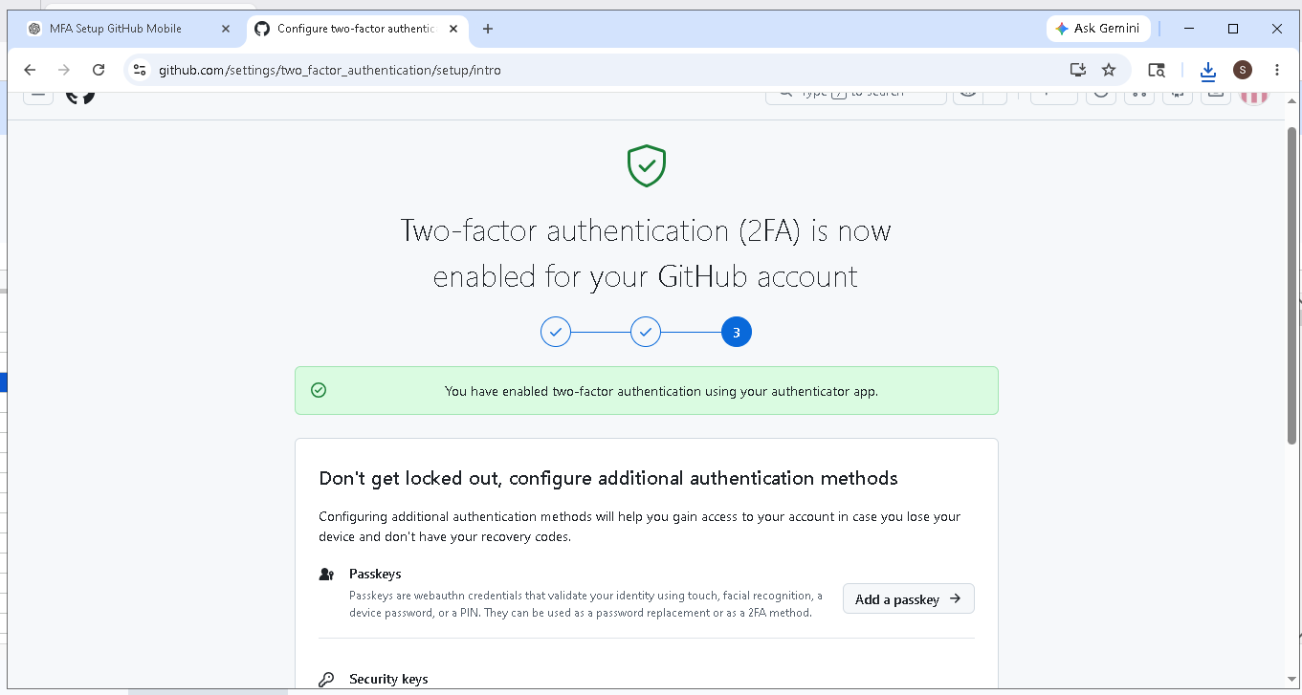

3.Execute all commands shown in the video:-
